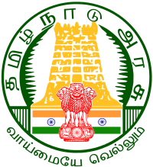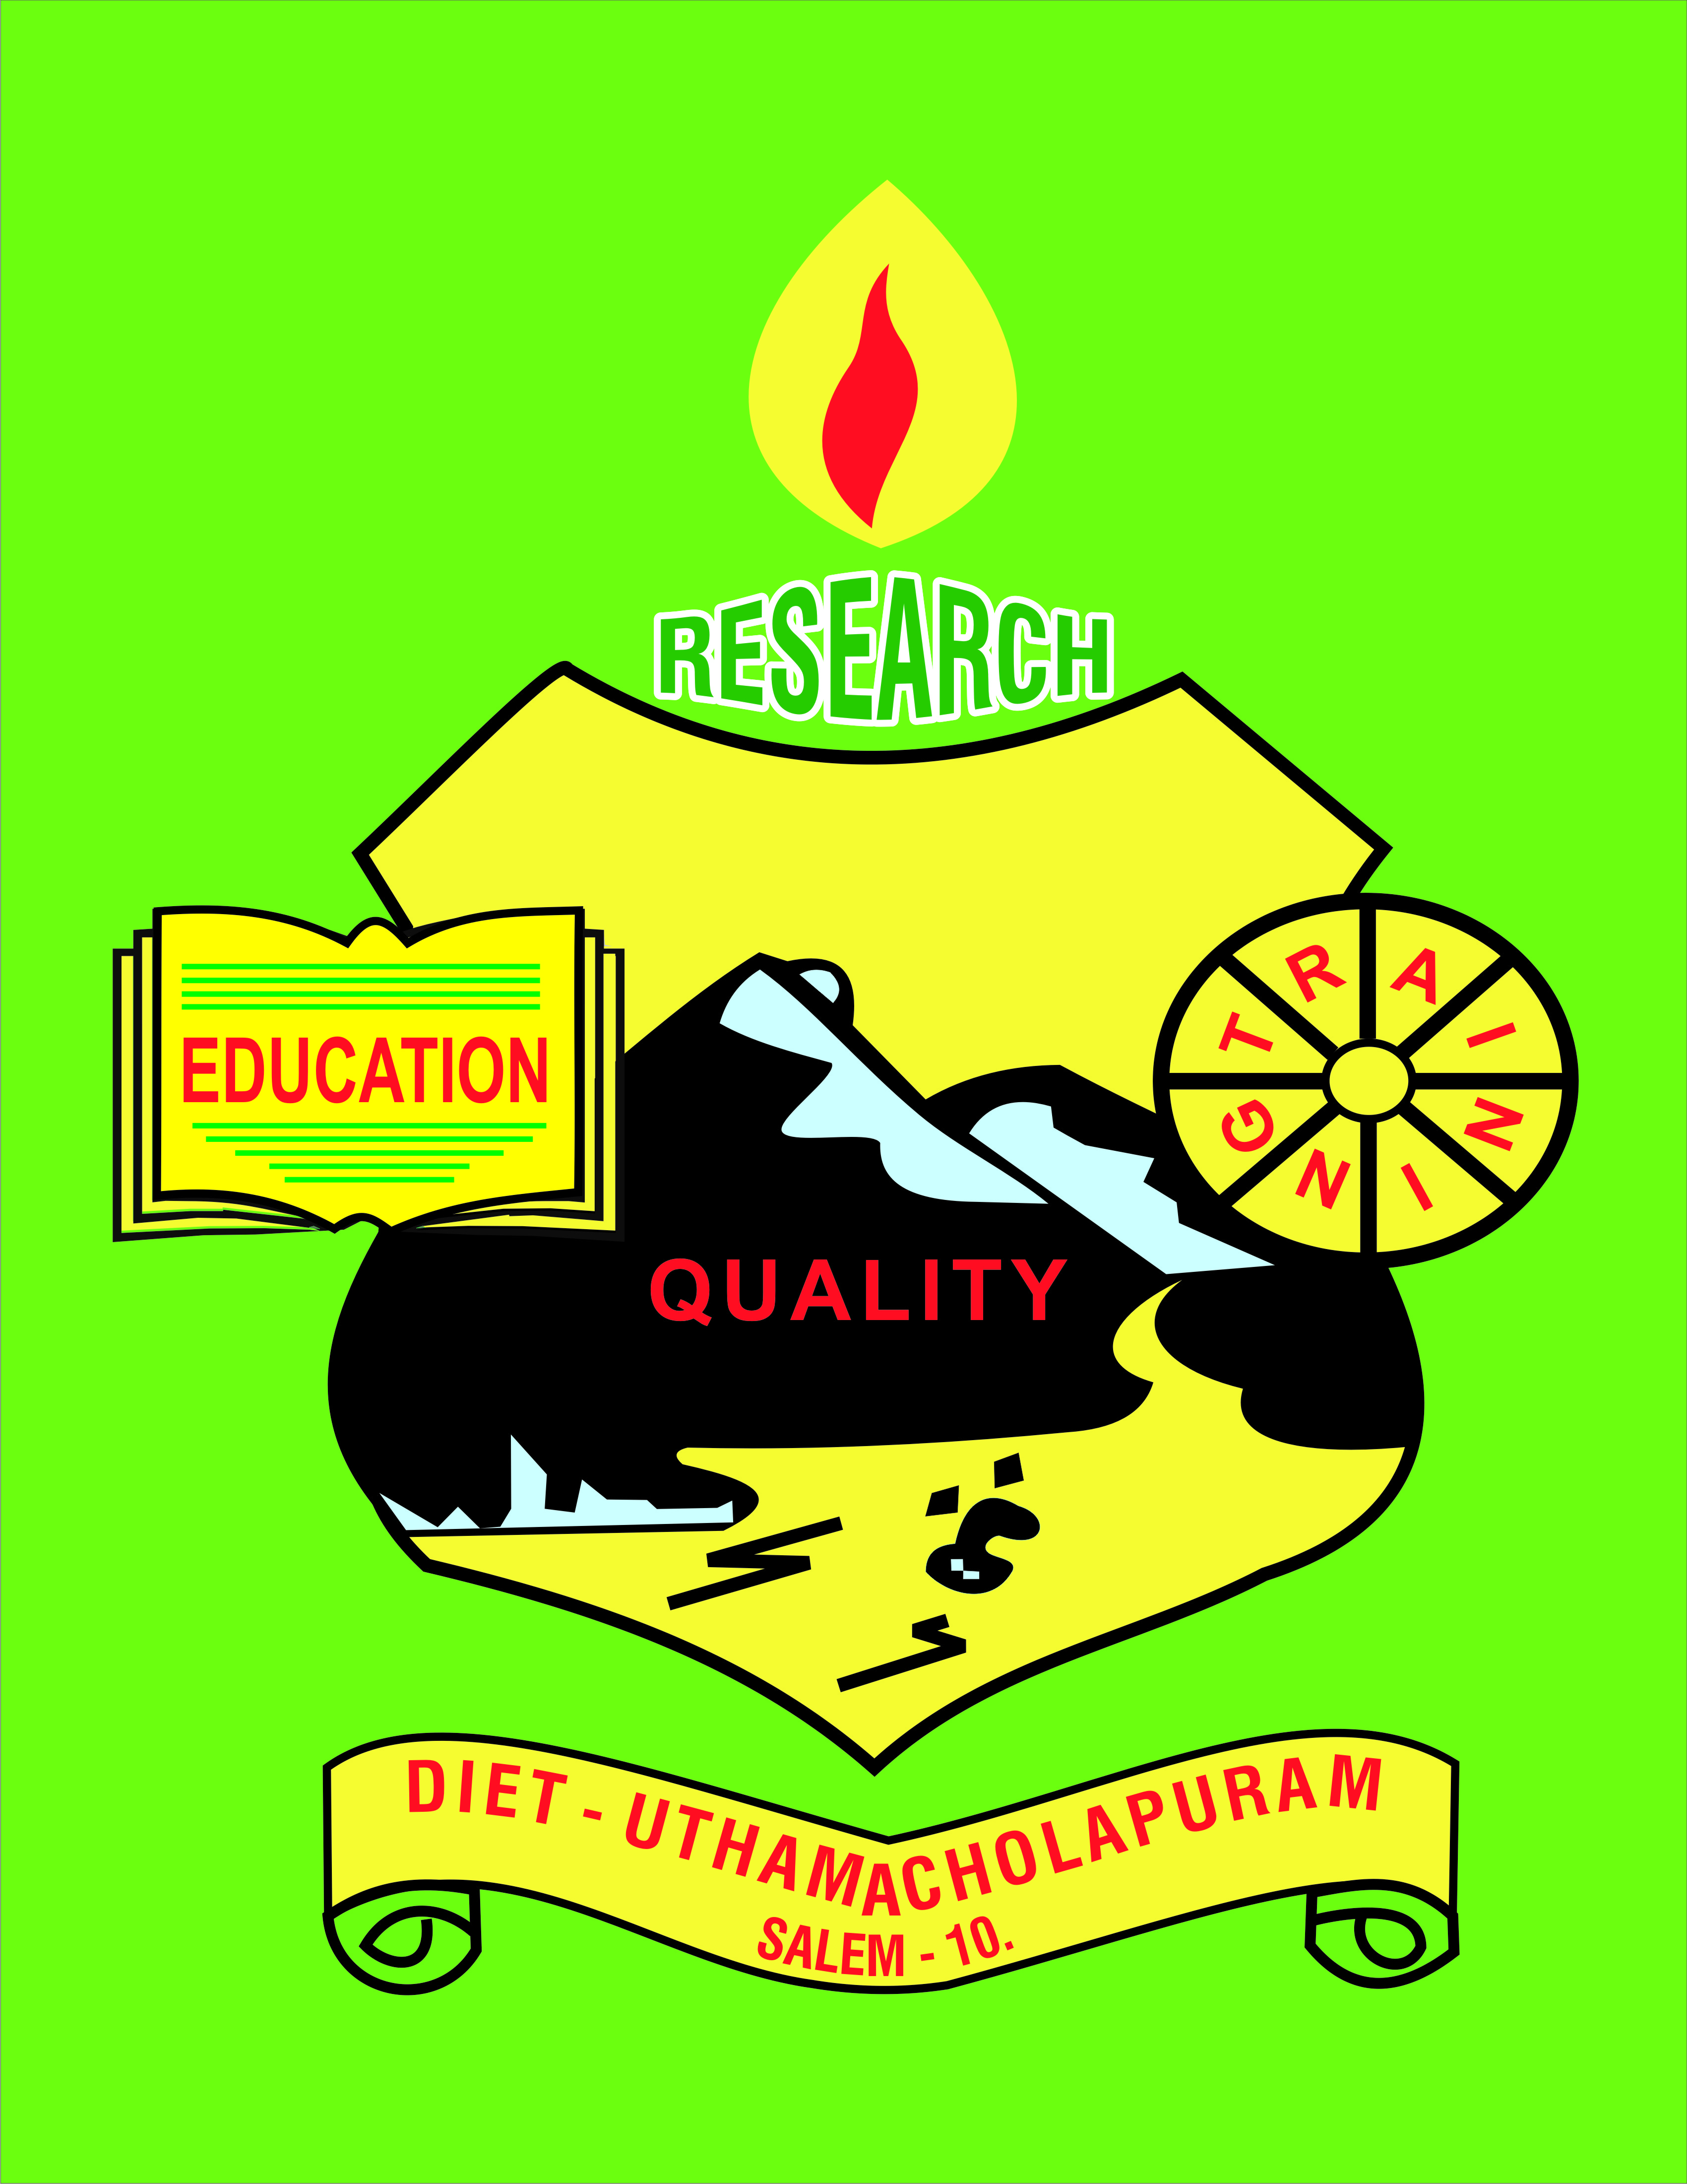

Uthamacholpuram,Salem-636010
January– 2023 PREPARED BY: ET-Branch Vol : 6 . S. No: 1

SPECTRUM
ECHO OF DIET SALEM
EE
Ece

Awareness of Educational Rese

Scientific Advancements that Shocked the World a Little
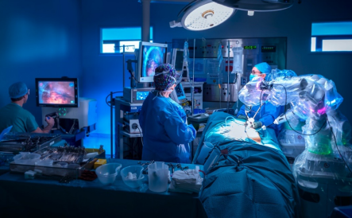
Technology is changing the world and making it a better place to live in, with new inventions and discoveries every passing moment. We are all a product of evolution, growing into who we are from specs of dust; we have come a long way in being called the most intelligent species in the universe. We call it the universe, some call it energy, and some consider it a sort of frequency that decides our higher orientation, but whatever it is that is keeping the universal beings intact is doing a great job and is excelling in it. Human beings are doing their best to keep the wheel moving; from primarily living on land, creating their food from whatever they had, generating fire to landing in space, we have come a long way. As far as technology is concerned, it has eased our ways of living but has also gripped us into a cobweb where it is difficult to stay away from the wired network and now a wireless ecosystem that has taken aboard our further developments.
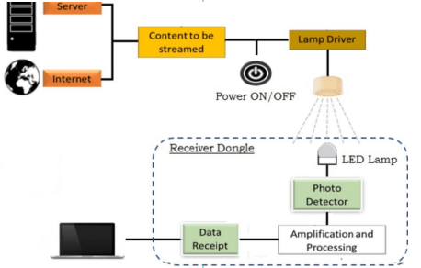
There are interesting ways by which technology has charmed us and made us all its lifetime addicts and partisans. The future seems even more approachable now. We come from the times when the postal service was meant to be a fast horse carrying light carriages to deliver; it used to be called cursuspublicus (62BCE-14CE).
Look at us now, calling our friends and family living 1000 miles away just in a blink. This isn't all; we are living in an ecosystem where everyone has access to almost everything, depending on how destructive or constructive the use may be. We have Scientific Advancements that Shocked the World a Little!!
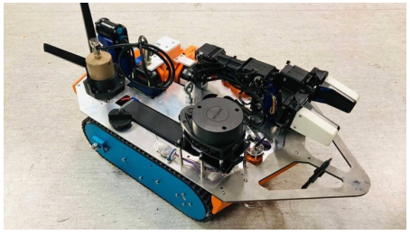
We have read almost all genetic codes, explored human bodies and their functions, developed robots, had quite a good excursion to the moon and mars, fought nuclear wars, and seen a pandemic washing away half of our population from the face of the earth. Life has taken its turn by providing us with a lot to witness and experience in the numbered days of one’s lifetime. This isn't what we accounted for as we began our journey on this land; we grew on our primitive knowledge and added some intellect. The concoction of knowledge, wisdom, wit, need, and competitive spirit of beings, we started bringing in technologies to ease and complex our lives altogether.
How did we achieve it all? The only way is expansively growing technology; we are spectators and creators of some of the most significant inventions that are ruling the world and are a pedestal to a completely reformed, technically stronger future than ever.
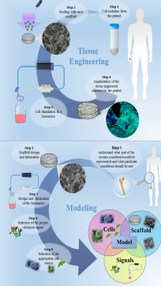
Advancements in science and technology blew our minds and gave us a completely new perspective.
Medical robots- Prometheus, interstellar, and many more movies gave us a lead Do you remember watching those movies where robots perform surgeries using plastic tubes and stainless-steel equipment, Seems unreal? It isn't anymore; some companies are working on creating robotic techniques that not just assist but perform complete procedures, from stitching a suture wound to performing tricky cardiac surgeries.
How promising is the technique? The technique is used to treat conditions that affect visceral organs like the heart, bladder, and kidney. Robotic technology has proven to reduce blood loss significantly, and as there are fewer chances of error, it promises quick recovery. Surgeons are not going off jobs with this technology, and these surgeries are performed under the complete supervision of surgeons who are well-trained to use it.
Still,a long road for this to rule the world. Why? → Not available throughout the world; only the hospitals that have funds to afford it and have surgeons to perform it can make it happen. → Larger incisions are needed to be made in the body to let the instrument invade, which makes it a little tricky. → There are high risks of compression and nerve damage. With all its merits and demerits, robots doing our surgery and helping us heal is another level of imagination.
Li-Fi Does the term sounds familiar? Does it have a rhyming technology buzzing in your head? Yes, you thought it right. It's similar to Wi-Fi, as we are aware of, and have been using wireless fidelity for quite a time now; light fidelity is quite thought-provoking. Imagine living in a world where connecting to high-speed internet can be achieved with a simple light switch flick. Li-Fi is a type of wireless optical networking that transmits data using LEDs. Li-Fi is sometimes referred to as a light based Wi-Fi because it transmits data by light rather than radio frequencies. Li-Fi offers a few benefits, including operating in environments susceptible to electromagnetic interference, such as hospitals and airplane cabins, and operating across greater bandwidth while providing faster transmission rates. It is considered to be 100 times faster than Wi-Fi.
Various agencies around the world are developing this technology. How is it possible? How does the technology work? A system called Li-Fi uses visible light to conduct wireless internet connections at very fast rates. With the use of this technology, an LED light bulb may emit light pulses that are invisible to the human eye and allow data to be sent to and received from receivers. The receivers then gather data and translate the delivered information. This is essentially comparable to deciphering Morse code, but it happens millions of times each second, which is significantly faster. Li-Fi, also known as the world's fastest Wi-Fi, has transmission speeds of over 100 Gbps, which is 14 times faster than WiGig. Isn’t it fascinating to see how easy it is to connect with the world by just turning on the lights in your room?
Nuclear inspection robots We all have heard of nuclear accidents in Chernobyl, and many other parts of the world, which have left a huge dent in humanity, and even after decades since the incidents took place, we are still dealing with its repercussions.
Lunokhod 1 and other lunar rovers were famously used in clean-up operations after the Chernobyl nuclear power plant disaster to cross the radioactive terrain, with varying degrees of effectiveness. Because the moon lacks an atmosphere and is subject to radiation, lunar rovers were explicitly chosen for their ability to tolerate it. Lyra, a brand-new nuclear inspection robot, is now joining the fray.
According to Tech Xplore, Lyra was shot through 140 meters of ductwork in the Scottish nuclear plants at Dounreay. Five radiation detectors, two cameras, lights, a robotic arm, and a mapping LiDAR system are all included in Lyra. Lyra was able to make a 3D video map of the area she had investigated, thanks to the complete set of tools. The video Lyra returned had readings of radiation hotspots superimposed on top of the photographs using the radiation sensors. As we deal with nuclear accidents like those at how it is Chernobyl or Fukushima, robots like Lyra could allow for a more comprehensive mapping of radiation dangers, minimizing the need for humans to be exposed as we try to deal with incidents like those in Fukushima and Chernobyl.
Regenerative medicine:
The human body contains a variety of built-in mechanisms for self-healing. Skin cuts heal on their own, damaged bones recover, and a living donor's liver regenerates in a matter of weeks. Imagine if researchers could harness this innate capacity for healing and use it to treat various diseases. Diseases like chronic heart issues, stroke, diabetes, and arthritis have long-lasting symptoms and adverse effects on the human body, and they do not resolve independently.
However, conditions can be managed and contained with medication and certain medical interventions. But regenerative medicine focuses on managing diseases by supporting the body to repair and regenerate its degenerated cells and restoring its ability and state of well-being. Regenerative medicine therapies stimulate the body to conduct a self-healing response in anything from prenatal surgical interventions to treatments for lifelong degenerative and debilitating illnesses.
These developments in patient care across a broad spectrum of medical professions point to fresh approaches to improve and sustain optimum health and quality of life. Instead of the present clinical approach, which mostly focuses on treating the symptoms, regenerative medicine tries to replace tissue or organs that have been harmed by disease, trauma, or congenital problems.
Tissue engineering, cellular therapy, medicinal technologies, and artificial organs are the means employed to achieve these results. Combinations of these methods can replace an organ that has been course of action is to find a donor and wait for the donor's body to react to immunosuppressant’s to donate the targeted organ. The whole process has its side- effects, and after crossing that stage, it is not always possible for the recipient's body to accept the organ.
The regenerative cells can be a great revival strategy in such cases. Scientific development has solved practical problems and has been helping researchers and laypeople to make informed decisions. As the products of science and knowledge are so fruitful, their process is mostly intertwined with the applications. New knowledge every day is leading us to newer applications every second. Isn't it a great motivation to leave those gaming screens a little rest and wrack our brains a little more? Who knows, you can be the next one to invent or discover something meritorious for our growing world?
Irreparably damaged or enhance our body's natural healing process where it is most required. In the relatively new field of regenerative medicine, experts from biology, chemistry, computer science, engineering, genetics, medicine, robotics, and other disciplines collaborate to find solutions to some of the most difficult medical issues humanity has ever faced.
The burgeoning discipline of regenerative medicine aims to repair the structure and functionality of organs and tissues that have been injured. Additionally, it aims to develop remedies for organs that sustain lasting harm. The objective of this strategy is to discover a treatment for ailments and injuries that were previously incurable. The significant concentration in the field of regenerative medicines
1. Biomaterial and tissue engineering- scaffolds that have biological compatibility with the damaged tissue are implanted at the site of tissue generation. The important point to cater to is keeping the scaffold in the same geometric shape as the tissue. The scaffold then starts attracting cells to form new tissue as desired. The field is still juvenile, as most of the successes have been seen with soft tissue generation.
2. Creation of artificial organs – in case of organ failure, the usual course of action is to find a donor and wait for the donor's body to react to immunosuppressant’s to donate the targeted organ. The whole process has its side- effects, and after crossing that stage, it is not always possible for the recipient's body to accept the organ. The regenerative cells can be a great revival strategy in such cases.
Scientific development has solved practical problems and has been helping researchers and laypeople to make informed decisions. As the products of science and knowledge are so fruitful, their process is mostly intertwined with the applications. New knowledge every day is leading us to newer applications every second. Isn't it a great motivation to leave those gaming screens a little rest and wrack our brains a little more? Who knows, you can be the next one to invent or discover something meritorious for our growing world?
8 January 2023.-AsthaSachdeva: The author is an active Science Communicator. Email: astha.1390@gmail.com
Dr. M. Selvam, Principal
Visited the “Ennum Ezhuthum” Block Level Training centers as follows:
Date | Name of the union level training center
02.01.23 | GHSS Panamarathupatty , Veerapandy, CSI- Hasthampatti, St. Joseph Primary School, Yercaud,Salem.
03.01.2023 | GBHSS Vazhapady, Pethanaikanpalayam, GET Matriculation HSSchool, Gangavalli ,Salem.  Bharathiyar Art’s and Science College, Deviyakurichi.,Salem.
04.01.3023 | Padmavani Arts and Science college, Salem GBHSS Sankagiri, Swamy CBSE School , Ayothiapatnam,Salem.

- Inaugurated district curator WhatsApp group for as assessment questions at AVS Arts and Science college, Ayothiyapatnam on 03.01.2013.
- 05.01.2023 to 06.01.2023-Visited AVS Arts and Science College, Ayothiyapattinam for assessment questions preparation workshop.
- Inaugurated induction training for newly recruited PGT( Commerce and Accountancy ) at AVS Arts and Science College , Ayyothiyapatnam on 11.01.2023 and the Second batch on 30.01.2023.
- Initiated “Kathai Aruvi” Story cards the reading project at PUMS Vazhadasampatty, Mecheri block on 19.01.2023.
- Inaugurated the Intervention of Teachers Actions Research programme at GGHSS Tharamagalam Block and visited PUMS Aarupatty on 25.01.2023.
- Inspected on the attendance of ST Students in Ezhil-TTI,Kolathur and Visited PUPS- Thookkanampatty on 27.01.224.
- Acted as Resources Person in the Tamil Nadu Leadership programme ( HM’s Training at Pillar Hall, Madurai on 31.01.223.
- Participated in the Valedictory function of induction and training for newly recruited PGT at AVS College, Salem.
PRE - SERVICE TEACHER EDUCATION: (PSTE)
Dr. P.Govinda Prakash, Senior Lecturer
02.01.2023  to  04.01.23 | Coordinated “Ennum Ezhuthum”-Term- III block level training at CSI TTI, Hasthampatti, Salem.
06.01.2023  to  11.1.2024 | AWPB Annexure A B C preparation work was carried out at DIET.
18.01.2023 | EE – Term-III- office work was seen at DIET.
23.01.2023 | Google sheet uploading work to SCERT was done at DIET.
24.01.2024 | Visited School for Ennum Ezhuthum classroom activities at Salem Rural Block.
25.01.2023 | Research project preparatory work was seen at DIET.
27.01.2023 | Visited Ezhil-TTI at Kolathur with principal .
28.01.2023 | Participated Bamboozle and Scratch Programme at DIET.
30.01.2023 | Coordinated Higher Secondary , PG Teachers induction training at AVS Arts and Science College Ramalingapuram, Ayothiyapatnam, Salem.

Mrs S.Selvi, Lecturer
02.01.2023 to 4.01.2023-Cordinated and organized “Ennum Ezhuthum”-Term –III training programme for block level primary school teachers at GHSS, Magudanchavadi, Salem.

Mr.R.Ravi, Lecturer
02.01.2023 to 4.01.2023-Cordinated and organized “Ennum Ezhuthum”-Term –III training programme for block level primary school teachers at NSIT College,Salem.

IN-SERVICE FIELD INTERACTION INNOVATION AND COORDINATION : ( IFIC)
Dr.Ramesh Kumar,Lecturer
02.01.2023, 03.01.2023 & 03.01.2023
Organised block level “Ennum Ezhuthum” training at Padmamavani College of Arts and Science. Dr M.Selvam, Principal, District Institute of Education and training, Uthamacholapuram, Salem), Mr Santhosh (District Educational Officer (Elementry), Salem were visited the training programme and motivated the teachers. 180 teachers handling Classes 1, 2 & 3 in Omalur block were participated in the training programme.
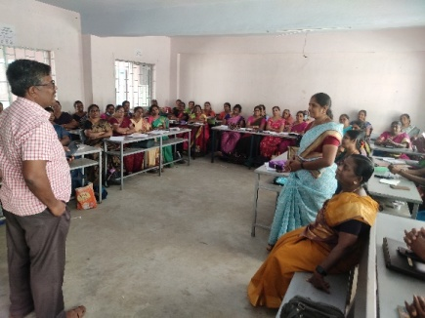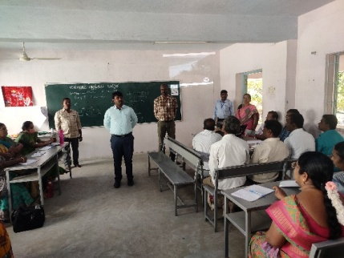
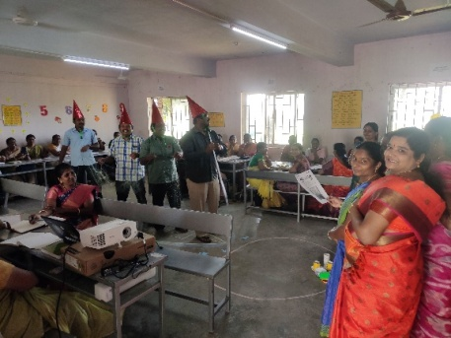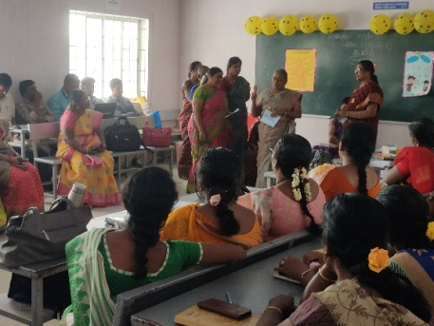
05.01.2023, 06.01.2023 & 11.01.2023
Involved in AWP&B 2023-2024 Planning work, Discussion and Documentation work at DIET.
08.01.2023, & 21.01.2023
Organised online guidance and review meeting for App Creators at DIET.
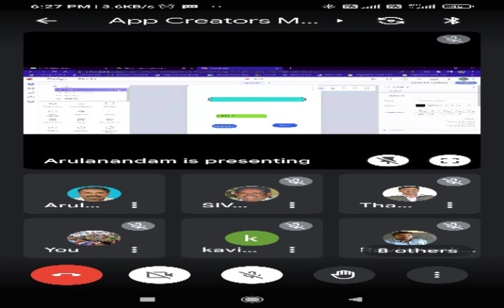
13.01.2023
Involved in Pongal celebration in DIET campus and participated in ‘story card’ reading activities.
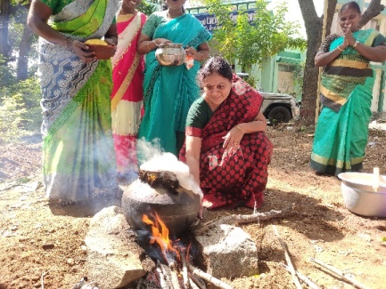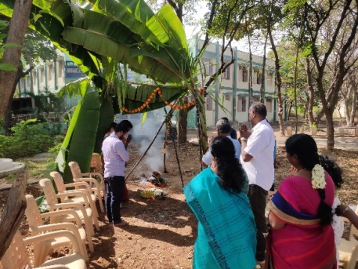
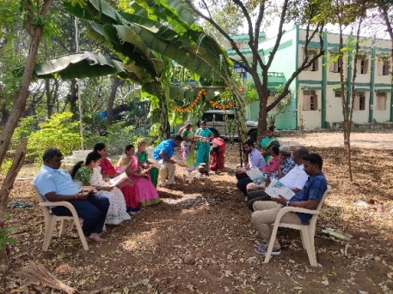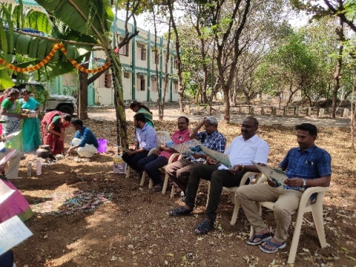
19.01.2023
Participated in the online review meeting conducted by Tamil Nadu State Leadership Academy at DIET.
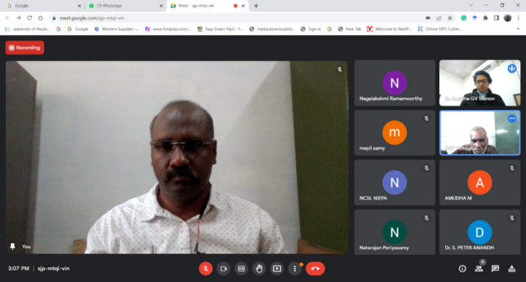

27.01.2023 & 27.01.2023
Attended National Seminar organised by Central University Tamil Nadu at Tiruvarur and presented a paper entitled “A Study on Teachers Professional Development during the COVID-19 Lockdown Period”.
30.01.23, 31.01.23 & 01.02.23
Coordinated refresher training for newly recruited Post Graduate Commerce Teachers in AVS College of Arts and Science. (GTR, ADW, Corporation schools)
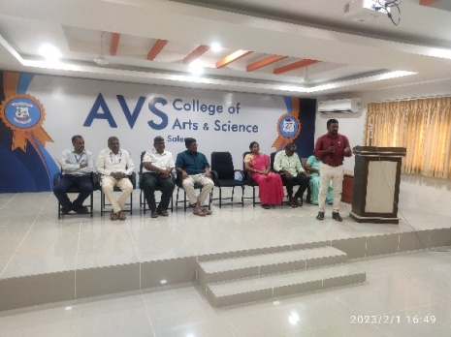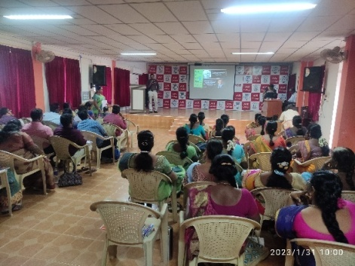
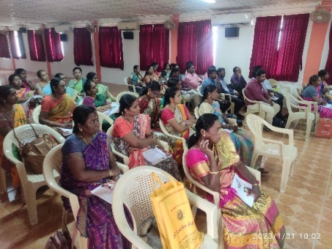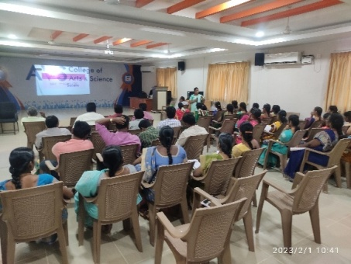
Mrs. M. Mahakakshmi, Lecturer
07.02.2023 | Attended CRC - KRP training at Presidency School, Chennai.
08.02.2023 | Pre-Planning work for district level CRC training was seen at CSI-TTI,Hasthampatti,Salem.
09.02.2023  to  10.02.2023 | Organized and Co-ordinated District level CRC training at CSI-TTI, Salem.
11.02.2024 | Visited CRC at GBHSS- P N Palayam, Salem.
17.02.2023 | Attended Palliparvai -App creation training at St Joseph Matriculation Hr.Sec. School ,Gugai,Salem.
20.02.2023  to  22.02.2023 | Attended workshop on Testing Device project tool preparation at DIET.

EDUCATIONAL TECHNOLOGY BRANCH: (ET)
Dr G.Dhanammal,SeniorLecturer

- Acted as coordinator for Term-III –“Ennum Ezhuthum” training at GHSS Varanasi on 01.01.2023 to 02.01.2023.
- Acted as co-coordinator MCQ Preparation workshop BME Taxonomy Work at DIET on 05.01.2023.
Mrs. M. Jayamani, Lecturer
- Acted as coordinator for “Ennum Ezhuthum”-Term-III block level training at GGHSS Edappadi on 02.01.2023 to 04.01.2023.
- Acted as coordinator - MCQ Preparation workshop for BME Taxonomy Work at DIET on 05.01.2023.
- Acted as Coordinator for “Ennum Ezhuthum” programme success story poster creation at DIET.
Dr V.Suganya, Lecturer
- 02.01.23 to 04.01.23- Coordinated “Ennum Ezhuthum” Term –III at Sri Swamy International School, Ayothiyapattinam Block.
- 04.01.2023- Attended Staff meeting conducted by Principal regarding AWP&B-2022-23.
- 06.01.2023-Involved in branch wise training proposal preparation work & Capacity building documentation preparation work at DIET.
- 09.01.2023- Extension activities programe documentation work was seen at DIET.
- 10.01.2023to12.01.2023- Coordinated 6thstd English summative question preparation workshop at DIET.
- 22.01.2023- Coordinated and conducted ‘AGAM, NENJAM,ULLAM’ programme, by Resource Person Dr Senthilkumar, Chairman, Helix open School & Learning Centre.
- 25.01.2023-“Ennum Ezhuthum” Classroom observed at PUMS C.Thathanoor , Ayothiyapattinam Block.
- 11.01.2023 &27.01.2023- Involved in “VangaVasikalam” Video Shooting at DIET.

DISTRICT RESOURCE UNIT: (DRU)
Dr P.SO.KESAVAN, Lecturer
- Coordinated Ennum Ezhuthum (3 Term) Training for Class 1 to Class 3 Teachers at GHSS, Veerapandi from 02.01.2023
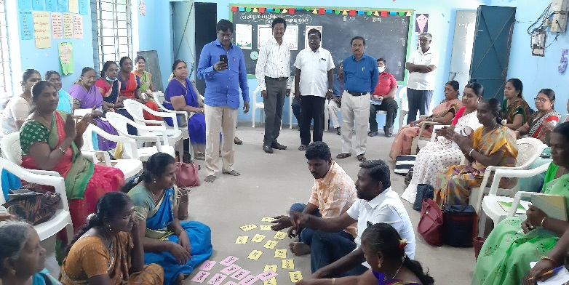 | 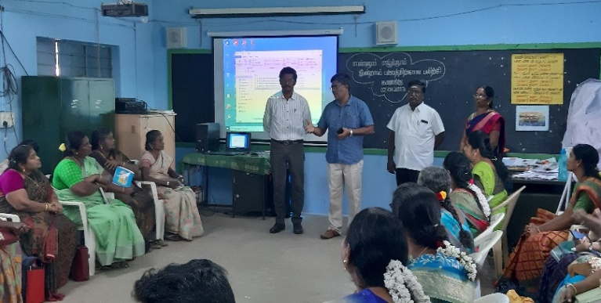
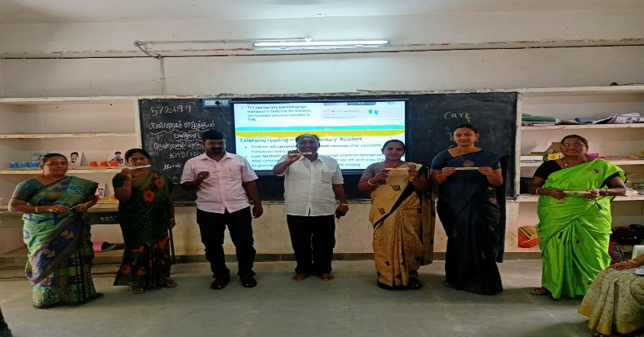 | 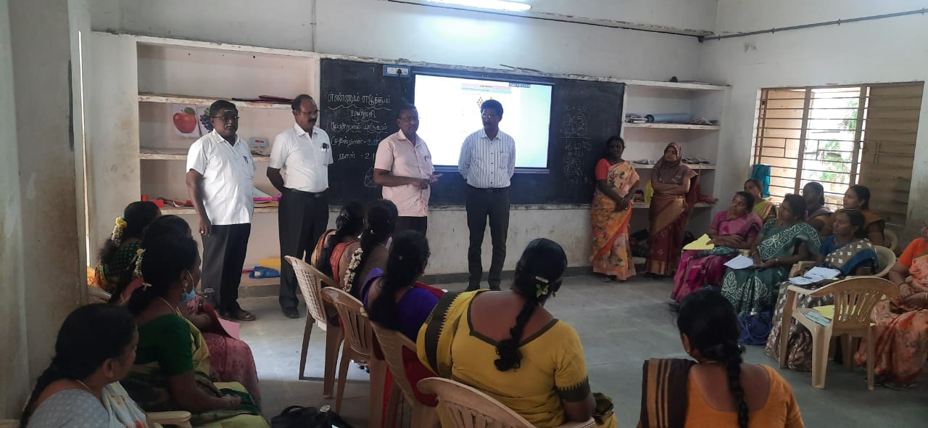
- Coordinated Video Mapping and Video rating workshop at BVHSS, Salem for XI and XII (Physics) on 10.01.2023 and 11.01.2023.
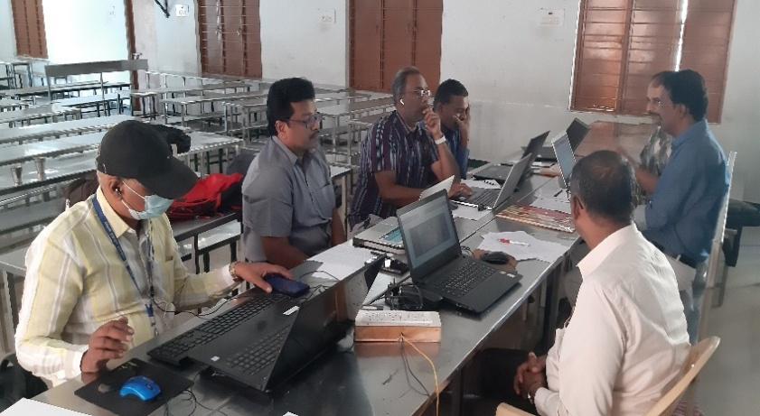 | 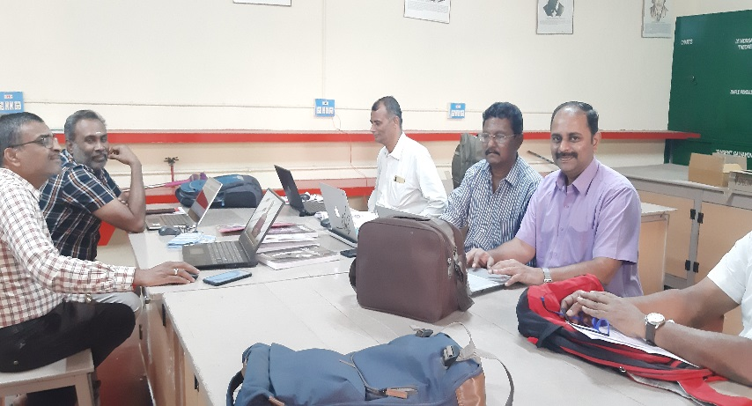
- Visited PUMS, Periyaseeragapadi,Veerapandy Block regarding Teacher Action Research--Identification of problem and Finalize the proposal on 13.01.2023 and 19.01.2023.
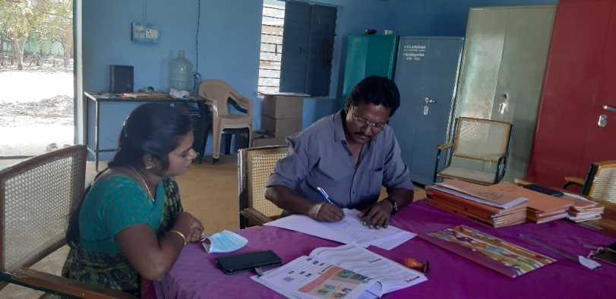
- Visited School at PUES, Thumbathullipatty,Veerapandy Block on 20.01.2023
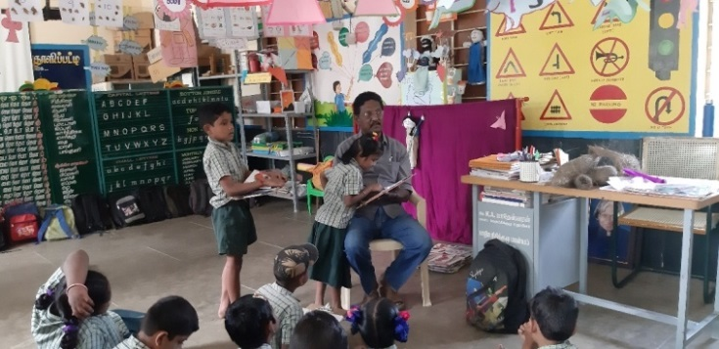

CURRICULUM, MATERIAL DEVELOPMENT &EVALUATION: (CMDE)
Dr R. Nagalakshmi, Senior Lecturer
Date | Details of Work Carried Out
02.01.2023 | Coordinated “ Ennum Ezhuthum “ Training – Term-III at GBHSS Valapady- subject Mathematics.
03.01.2023 | Coordinated “Ennum Ezhuthum” Training – Term-III at GBHSS Valapady- subject –English.  DIET Principal visited and delivered inaugural speech to training participants.
04.01.2023 | Coordinated “Ennum Ezhuthum “Training – Term-III at GBHSS Valapady- subject-Tamil. (DD- SCERT Visited EE center).
05.01.2023 | Settled documents and vouchers of EE –Term –III training at DIET office.
06.01.2023 | Attended Principal staff meeting regarding orienting teachers towards assessment tools at DIET.
09.01.2023 | Attended Principal staff meeting regarding AWP&B- 2022-23.  Action Research and Research proposal preparation work at DIET.
10.01.2023 | Participated in Discussion with Principal regarding “Kathai Aruvi “ programme at DIET.
12.01.2023 | Model Question Paper Preparation for class XI XII for BME was uploaded.
13.01.2023 | Celebrated “Pongal” festival at DIET campus.  Model Question Paper preparation for class XI XII for BCE subject and uploaded in the SCERT web portal.
18.01.2023 | Preparation of branch wise activities and programmes for AWP&B -23 was seen at DIET.
19.01.2023 | Visited Vadarasampatty Middle School for story cards distribution to upper primary students.
20.01.2023 | Video shoot made on Book Review of “Ordinary People and Extra ordinary teachers” by Mr. S Giridhar.
25.01.2023 | Visited School for Action Research Field work to Valapady block.
27.01.2023 | Visited School for Action Research Field work to Valapady block.
30.01.2023 | Visited School for Action Research Field work to Valapady block.  Action Research planning work was seen at DIET.
31.01.2023 | Visited School PUES Annanagar, Valapady for NILP.

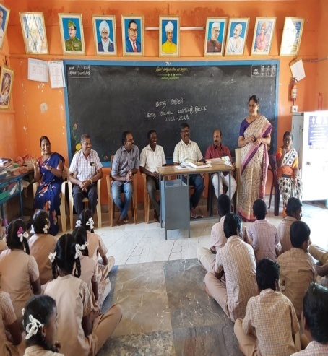
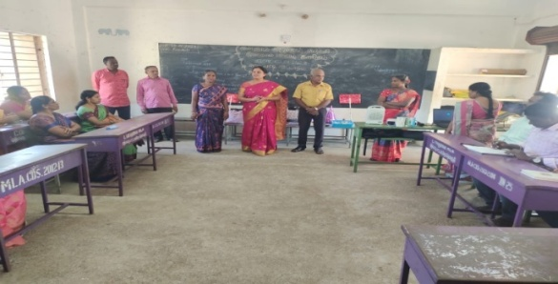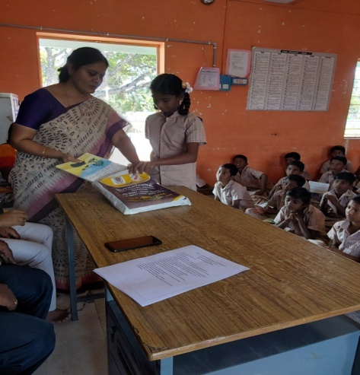

Dr. B. Ananthi, Lecturer
1. Monitored the conduct of ‘Ennum Ezhuthum’ (EE) at PUMS, Mittapudhur, Salem Rural Block on 27/01/2023. Mrs. G. Tharageswari handled Mathematics (Addition) for Classes 1 and 2, which were clubbed together based on the activities suggested in the “Ennum Ezhuthum” (EE module). Class 1 students were taught single digit numbers, whereas Class 2 students learnt double digit numbers. Class 3 was handled by Mrs. Sangeetha, in which students were involved in an activity to learn 3 digit number names.
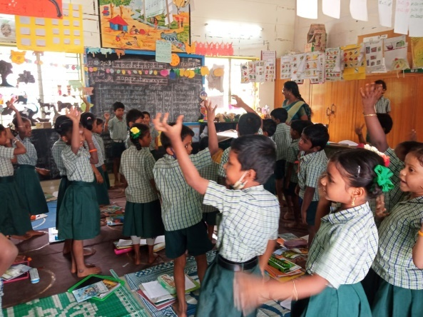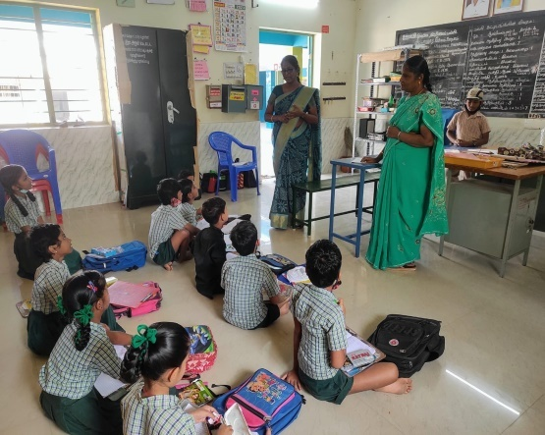

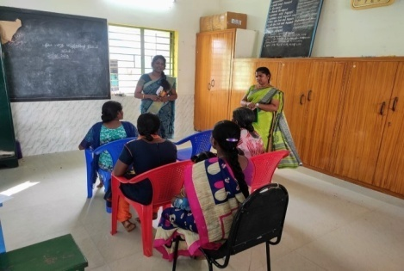
2. Visited ‘New India Literacy Program’ (NILP) on 27.01.2023, conducted at PUMS, Mittapudhur, Salem Rural Block. Only 03 participants attended the session, where 20 participants had registered. Ms. Sidheswari was the Volunteer in-charge of the NILP Centre. The participants were taught to write their names and also to sign. The participants were motivated to attend the classes regularly. The volunteer was motivated to bring the participants regularly to the session.
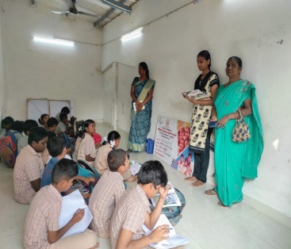
3. Visited ‘IllamThediKalvi’(ITK) Centre in the evening ( 4.40 pm to 5.50 pm) at PUMS, Mittapudhur, Salem Rural Block on 27/01/2023. 08Students of Upper Primary Classes attended the ITK session. The volunteer, Ms. T. Buvanewari was given feedback by the DIET faculty, to concentrate upon the areas that are difficult for the students to comprehend and also to make use of TLMs for the same.

PLANNING AND MANAGEMENT: (P&M)
Dr K. KANNAKI , Senior Lecturer
- Coordinated and organized Third term “Ennum Ezhuthum” training programme at CSI polytechnic College,Salem.
- Involved in preparation of Detailed Estimation report for DIET civil repair works , Flooring works and Roofing work from PWD office Salem.
- Acted as a coordinator for two day’s workshop for summative assessment for the standard 6th mathematics at DIET.
- Research questionnaire preparation work was done at DIET Salem.
- Research Questionnaire expert validation work and research discussion with experts was seen at Sarada College of Education ,Salem.
- Teachers name list was prepared for research module preparation work at DIET.

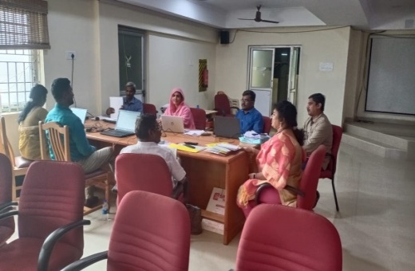
Mr . B.UTHAYAKUMAR, LECTURER
- Coordinated and Organized “Ennum Ezhuthum” Term-III- block level training programme for primary school teachers at Shree Satyam college of Engineering and Technology, Sankari on 02,03,&04.1.23.
- AWP&B-2023 state level Pay and Civil work Consolidation work was done at SCERT-Chennai under the Head of Dr Manivel, DD-SCERT,Chennai on 9th to11,19, 20 and 23rd to 25.1.2023.

Work Experience: (WE)
Dr S.V.VIJAYALAKMI SHANKAR, Senior Lecturer
- Coordinated “Ennum Ezhuthum”-Term III-Block Level Training programme at Sri Jaya Jothi College of Education Pavalathanoor, Tharamangalm Block,Salem.
- BCE –Taxonomy Question preparation and uploading work was seen at DIET.
- Coordinated Origami-4, 5 & 6th std Online Learning Google meet for students. Resource Person : Mr.Amalrajan Through Google Meet App Special programme AASAN AVAI organized by Dr S.V.Vijayalakmi Shankar, Senior Lecturer, DIET, Salem.
- Conducted AASAN AVAI 54 Online Programme : Resource Person: Mr.Janakiraman, BT Asst, Mattayampatti, Tharamangalam block. -Topic: ICT-HOT Potatoes.
- Conducted AASAN AVAI -55Online programme : Resource Person: Mrs.A.Hemavathi, Rtd HM, Vice –President PSF -Topic: “DO THE EXPERIMENTS BECOME A SCIENTIST”.
- Conducted AASAN AVAI -56 Online programme :Resource Person Mrs.A.S.Padmavathi, Writer -Topic: “Beyond the Curriculum…”
- AWP&B 2022-23 –Programmes&Activities Action plan Preparation work was seen at DIET.
- Annexure –C Compilation work was done at DIET.
- Acted as Jury for “Students Innovation Award through online”- at DIET.
- “INSPIRE AWARD” Programme -Acted as Resource Person for Teacher Action Research conducted at GGHSS, Tharamangalam Block,Salem.
- Attended Award giving function arranged for Immersive Technology Resource persons and Teachers.
C.ANBARASAN, Lecturer
- Co-ordinated Naan Mudhalvan- “Carrier and Guidance” students awareness programme to all nodal teachers in Government and Government aided school in Salem.
- 02.01.23 to 04.01.23- Coordinated EE-Term III-Block Level Training for Primary School Teachers at Kaveri College, Mecheri.
Dr.K.Kalavanan, Lecturer
- Co-ordinated Naan Mudhalvan- “Carrier and Guidance” awareness to all nodal teachers in Government and Government aided school at Gengavalli Block.
- Coordinated “Ennum Ezhuthum”-Term-III-Block Level Training programme at GET Matriculation HSS, Gengavalli Block, Gengavalli.
K.Satchidanandam, Librarian
- 02.01.2023 to 04.01.2023-Assisted and Coordinated “Ennum Ezhuthum “-Term-III training programme to all block centres along with DIET Principal.
- Initiated and Applied ISBN for DIET publications.
- Newsletters preparation work was coordinated with E.T branch.
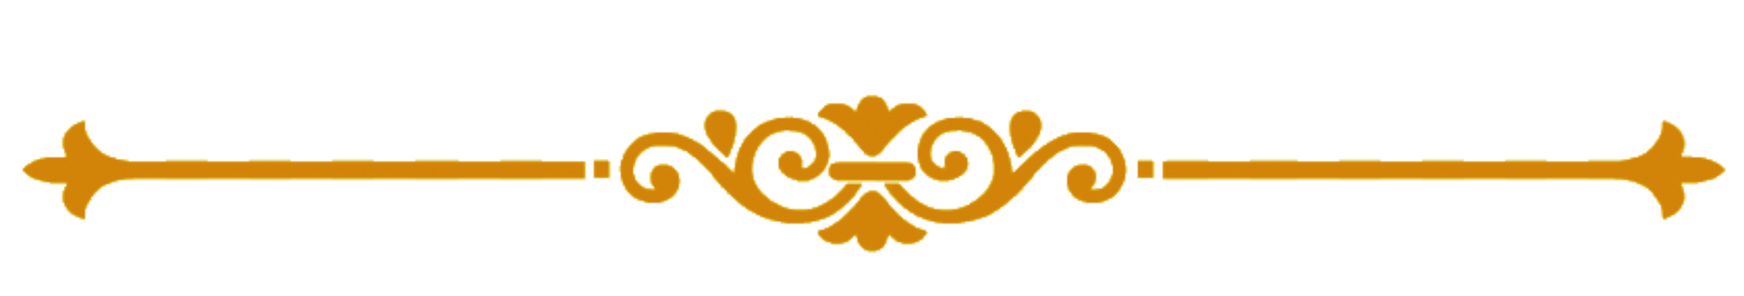
Chief Editor : Dr M.SELVAM,
Principal
Uthamacholapuram,
Salem-636 010
Edited and Published by : Publication Division- DIET, Salem.
Phone : 7373003460
Website : www.dietsalem.com
Mail Id : dietslm@gmail.com

